Welcome to Creative Stars Academy!

We are thrilled to provide your child, and your family, with quality learning and creative play opportunities. As part of the enrollment process, Creative Stars Academy is required to obtain additional information about your family. This helps support a smooth transition for your child into our program by allowing our staff to become well acquainted with your family and opens the door to ongoing family and center communication.

Creative Stars Academy Registration:

To finalize your child’s enrollment, please ensure each of the following items are fully completed. Your enrollment and assurance of your child’s spot is not guaranteed until each item below is received by the center director.

Additionally, you will be required to pay a one-time, $50 registration fee and a deposit. These payments are required to hold your child’s spot and to ensure availability for your family.
☐ Completed Registration Packet
☐Child information
☐Program Schedule
☐Scheduling Policy Acknowledgement
☐Primary Guardian
☐Secondary Guardian
☐Emergency Contacts/Authorized Pickups
☐Emergency Medical Authorization
☐Parent Authorization
☐Health Care Summary (Must be completed by Health Care Source)
☐Child Care Immunization Form

☐ Finalizing Registration
☐One-time non-refundable $50 Registration Fee
☐Hold fee/2-week Deposit of $165/week
☐Acknowledgment of CSA Contract
Questions may be directed to Creative Stars Academy at 507-258-2068 or emailed to director@creativestarsacademy.org

Child Information
Child
Last Name |  |  | First Name |  | MI | Nickname
Age | ☐ Male ☐ Female ☐ Prefer not to specify | Birth Date |  | Address City |  |  | Telephone Number:
Existing medical conditions, medications and/or special attention your child may require by our program

Allergies/Dietary Needs

Pediatrician’s Name | Phone | Address
Preferred Clinic/Hospital | Phone | Address
Dental Source (provide parent info if child has not been seen) | Phone | Address
Photos: May we take and maintain a photo of your child for security purposes? ☐ Yes ☐ No
Anticipated Days & Time of Attendance:
☐ Monday ____________A.M. to ____________P.M.
☐ Tuesday ____________A.M. to ____________P.M.
☐ Wednesday ____________A.M. to ____________P.M.
☐ Thursday ____________A.M. to ____________P.M.
☐ Friday ____________A.M. to ____________P.M.
Scheduling Policy
I understand that if the above schedule changes for any reason, I am responsible for giving Creative Stars Academy a 24-hour notice so that they may alter any staffing changes necessary. I understand that I may not bring my child earlier than opening time (6:00 a.m.), and no later than 9:30am without prior discussion, and acknowledge that a late fee of $1.00 is assessed for every minute that each child is left beyond closing time (6:00 p.m.). If a child is not picked up by 6:01 p.m. and no phone call is received, Creative Stars Academy is instructed to contact the police department for assistance after all other emergency contacts have been called.
☐ I acknowledge and understand the above Scheduling Policy

Primary Guardian Information
Name(s) of person(s) with whom child is living
1st Primary Guardian
Last Name |  | First Name |  |  |  |  | M.I. | Relationship to Child
Email Address |  |  | Work Phone |  |  |  |  | Cell Phone
Occupation | Employer |  |  | Work Address |  |  |  |  | Work Hours
Home Address | City |  |  | State |  |  |  |  | Zip Code
2nd Primary Guardian
Last Name |  | First Name |  |  |  |  | M.I. | Relationship to Child
Email Address |  |  | Work Phone |  |  |  |  | Cell Phone
Occupation | Employer |  |  | Work Address |  |  |  |  | Work Hours
Home Address | City |  |  | State |  |  |  |  | Zip Code
Which Primary Guardian Should be Called First? |  |  | Preferred language for written communication:
Mailing Address (if diﬀerent than above) |  |  |  |  | Apt # | City |  |  |  | Zip Code
Second Guardian Information
Non-primary custodial parent with whom the child is not living (if applicable)
1st Non-primary Guardian
Last Name | First Name |  |  | M.I. |  | Relationship to Child
Email Address |  | Work Phone |  |  |  | Cell Phone
Home Address |  | City State |  |  |  | Zip Code
2nd Non-primary Guardian
Last Name | First Name |  |  | M.I. |  | Relationship to Child
Email Address |  | Work Phone |  |  |  | Cell Phone
Home Address |  | City State |  |  |  | Zip Code
Which Guardian Should be Called First? |  | Home Phone |  |  |  | Should program communications be sent here?  ☐ Yes ☐ No
Second Household Mailing Address (if diﬀerent than above) |  | Apt # | City |  | State |  | Zip Code

Emergency Contacts and Authorized Pickups
For children’s safety, Creative Stars Academy will contact and release a child only to the parent(s)/legal guardian(s) and to those who are listed below (at least 2). Photo identification will be required to any of the following contacts.
1st Contact/Pickup
Last Name |  | First Name |  | Relationship to Child
Home Phone | Cell Phone |  | ☐ Able to pick up all children in the family  ☐ Not able to pick up the following children:
Home Address | City |  | State Zip Code
2nd Contact/Pickup
Last Name |  | First Name |  | Relationship to Child
Home Phone | Cell Phone |  | ☐ Able to pick up all children in the family  ☐ Not able to pick up the following children:
Home Address | City |  | State Zip Code
3rd Contact/Pickup
Last Name |  | First Name |  | Relationship to Child
Home Phone | Cell Phone |  | ☐ Able to pick up all children in the family  ☐ Not able to pick up the following children:
Home Address | City |  | State Zip Code
Emergency Medical Authorization
In the event of an emergency, I ________________________________, give Creative Stars Academy permission to obtain
(parent/guardian name)
emergency medical care and/or treatment for my child, __________________________.
(child’s name)
Parent/s Signature: ________________________________ Date: _________________
Parent Authorization (circle your answer)
- Creative Stars Academy staff is / is not permitted to administer sunscreen to my child

- Creative Stars Academy staff is / is not permitted to use my child’s name and/or to take pictures/video at the facility which can be shared with families, posted within our facility, used for ongoing staff professional development and promoted via social media including, but not limited to our website, Facebook, newsletters, news articles, etc.
- I do / do not permit my child to be observed by local early childhood students for practicum purposes
(all names and details will remain confidential)
Additional Comments & Information:
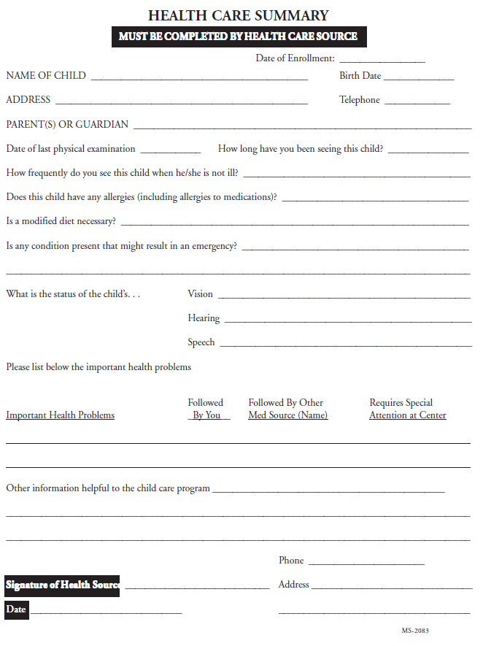
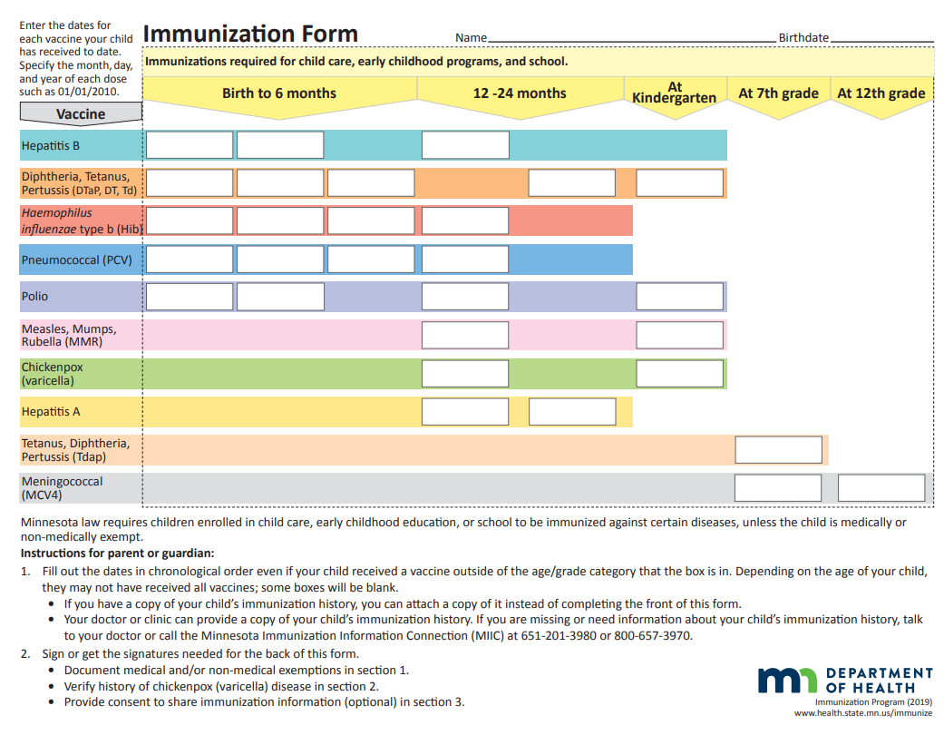
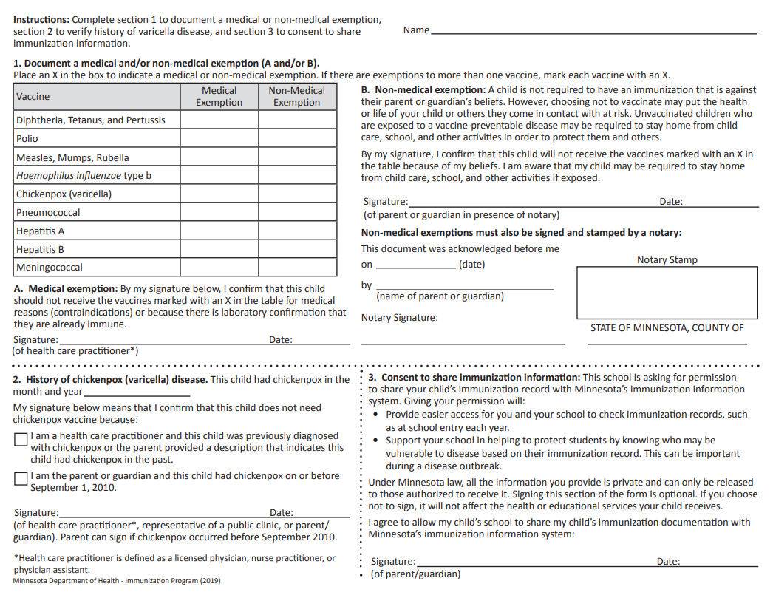

Finalizing Registration

Child’s Name: __________________________________ Date of Birth: __________________

Enrollment Date: ____________________ Classroom: ____________________

School-Age (Kindergarten through 12 years): A $50 one-time, non-refundable registration fee as well as a non-refundable two-week deposit ($330) is required to hold your spot.

Please submit the above registration forms and registration fees to:
Creative Stars Academy
1835 19th Ave. NW.
Rochester, MN 55901
or
director@creativestarsacademy.org

Please note, registrations will not be processed without the one-time Registration fee.

AUTHORIZATION:

$50.00 non-refundable registration fee + 2 weeks deposit in the amount of $_780___

☐Check Enclosed: Amount $__________ Check # ___________
I agree to pay the above total amount: ☐ Yes ☐ No

Signature: ________________________________ Date: ___________________

Creative Stars Academy Contract
This contract is made between the parent(s)/guardians:
_____________________________________________name of parent(s)
_____________________________________________address of parents(s)
And
Creative Stars Academy for the care of the following children:
child’s name _____________________________________ and date of birth ________________
The payment for care shall be $_____________ per week and reflects a schedule as follows with an anticipated start date of _________________________ (month, date, year):

☐ Monday ____________A.M. to ____________P.M.
☐ Tuesday ____________A.M. to ____________P.M.
☐ Wednesday ____________A.M. to ____________P.M.
☐ Thursday ____________A.M. to ____________P.M.
☐ Friday ____________A.M. to ____________P.M.
If a parent is going to be late picking up the child, every effort must be made to contact CSA. A late pick up fee of $1 will be charged for every minute child is left beyond closing time (6:00 pm).

Payment by direct withdrawal is due to CSA in advance for care taking place the following week and is to be paid every Friday by noon. Payment by cash or check is due on Monday for the week of by noon.
Accepted methods of payment include: cash, personal check, credit card, or money order.

If a personal check is returned due to a lack of funds, the parent/guardian must pay a $30 returned check fee. If a check is returned more than one time, only cash or money orders will be accepted as payment. If a payment is not made on time, the following fee will apply: $10 for every day thereafter.
State Payments:
If you are receiving state program funding, please list details of your payment policy on the following lines:
_________________________________________________________________________________________________
_________________________________________________________________________________________________Please Note: Families using state subsidy programs are responsible for paying any and all amounts not covered by the state.
Payments during Holidays, Vacations, and Other absences:
Creative Stars Academy will not be open for business on the following Holidays:
New Year’s Day President’s Day Easter Day Memorial Day Labor Day Independence Day Thanksgiving Day & The Day After Christmas Eve Day & Christmas Day
***Typically, if a holiday falls on a Saturday, Friday we will be closed. If the holiday falls on Sunday, Monday we will be closed. Days will be posted. Full payment must be paid for these holidays. These holidays are paid holidays for our Academy, for all children, full or part time.

If a parent plans on taking a vacation and the child will not be in care, CSA must be given four- week notice. Parents are expected to pay during their scheduled vacations.

When a child is ill, the parents are expected to make every effort to give CSA as much notice as possible. Parents are still expected to pay on days children may be out ill.

If a child does not arrive for the day and no notice has been given to CSA staff, parents are still expected to pay.

Termination Procedures:
This contract may be terminated by the parent(s) or the center. A two-week notice prior to the last date of care is required to do so.
Creative Stars Academy may immediately terminate this contract without any notice if payment is not made on time.

Other:
• If CSA chooses not to enforce any portion of the contract, it does not give up the right to enforce any other portion of
this contract.
• This contract can be revised at any time by Creative Stars Academy if necessary and CSA reserves the right to terminate care at any time for the following reasons:
- Continuous late pick-up
- False information of parent or guardian
- Continuous challenging behavior of child with lack of communication and help from the parents
- Any other reason deemed appropriate by Creative Stars Academy

Signatures:
The signatures below indicate agreement with this contract and with the written policies of Creative Stars Academy (contained in a separate document). Creative Stars Academy may change policies as needed with advance written notice.
__________________________ ___________________________
Parent’s name Parent’s signature/date
__________________________ ____________________________
Parent’s name Parent’s signature/date
__________________________ ____________________________
Creative Stars Academy signature/date
If the parent or legal guardian is under the age of 18, a co-signer must sign this agreement and act as guarantor to the contract and agree to be bound by all financial terms

